**What WE will Make Stylish Personal Site**

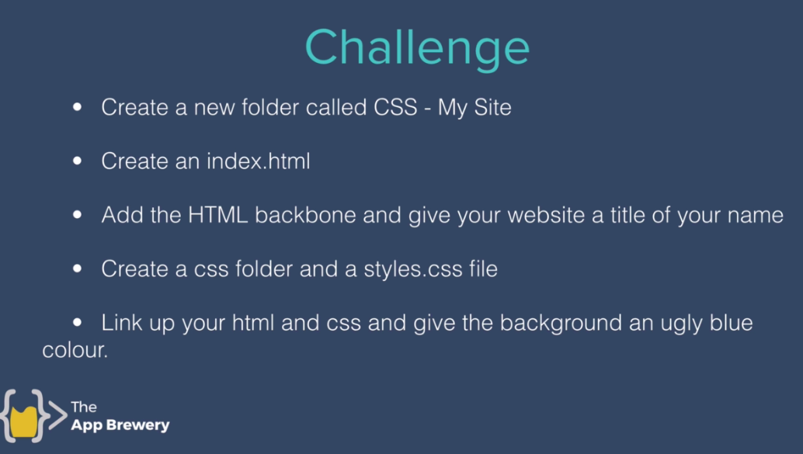

**Create Favicon to add along with site title**

<https://www.favicon.cc>

